4.Differences between Functional
and Non-Functional Testing

Module Name: Review & Inspection
Test Case ID: str_id_04
Webpage URL: https://www.browserstack.com/guide/functional-vs-non-functional-testing

- Overview
Software testing covers more than just verifying whether features work as expected. It also involves evaluating aspects like performance, security, and usability. This distinction is captured in two broad testing categories: functional and non-functional.
While functional testing ensures feature correctness, non-functional testing guarantees broader standards of reliability and user experience.

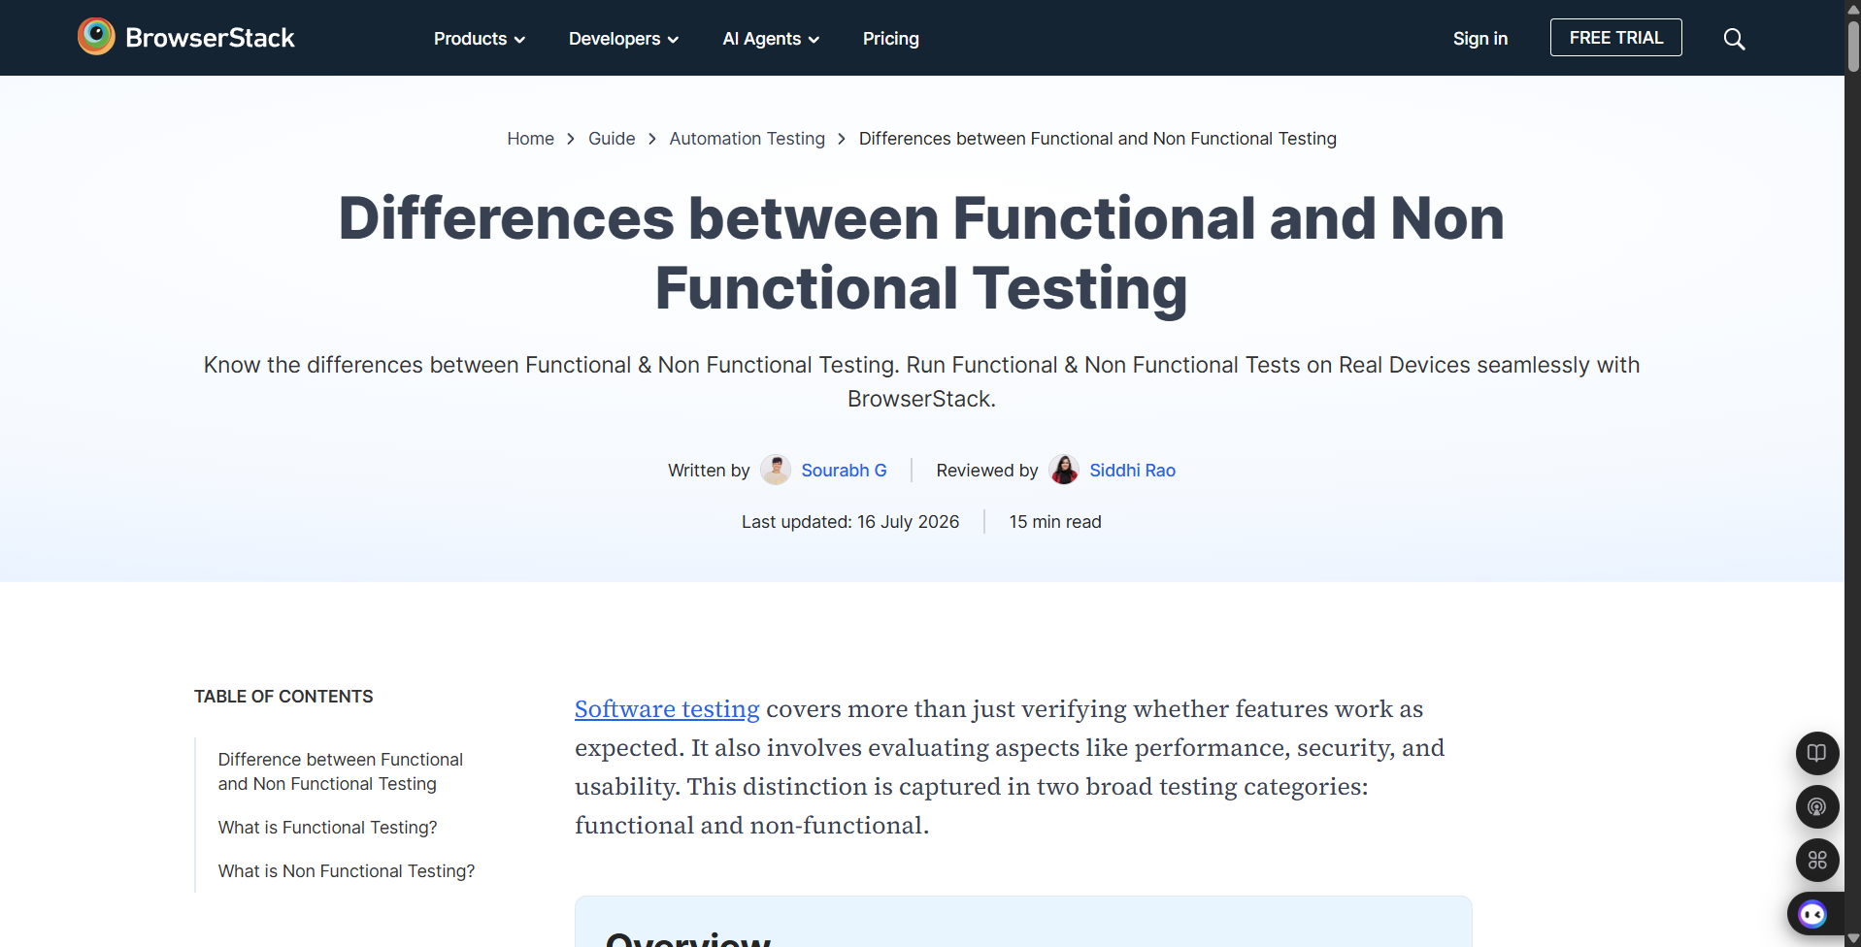

- Functional vs Non-Functional Comparison
2.1 High-Level Comparison
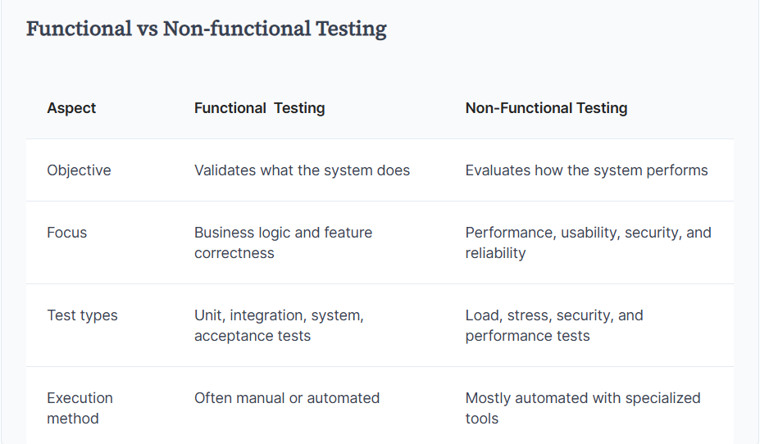
2.2. Detailed Comparison
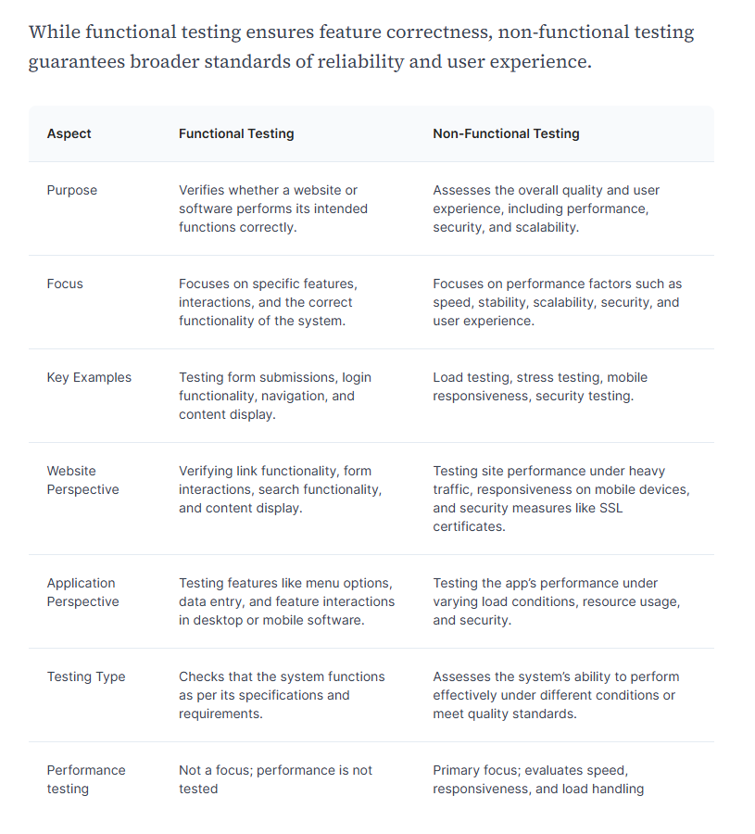

- What is Functional Testing?
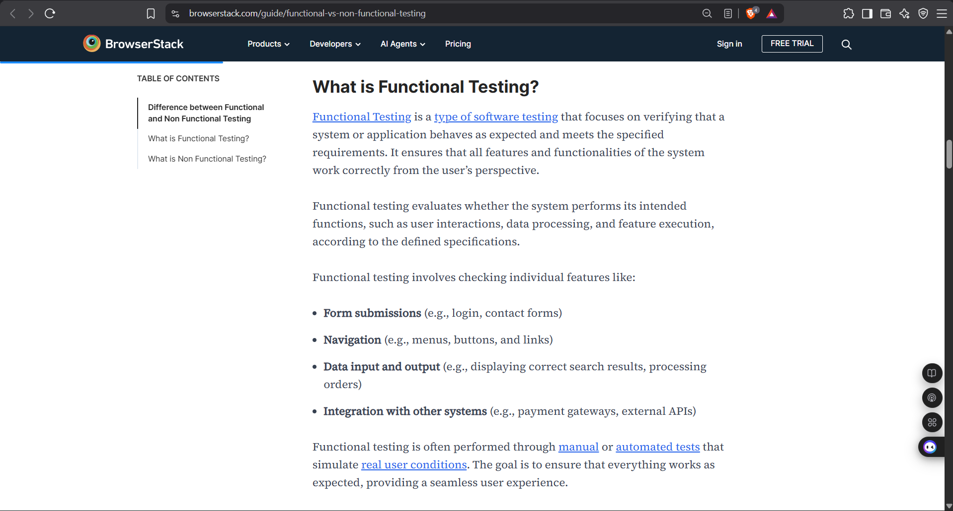
Functional Testing is a type of software testing that focuses on verifying that a system or application behaves as expected and meets the specified requirements. It ensures that all features and functionalities of the system work correctly from the user's perspective.
Functional testing evaluates whether the system performs its intended functions (user interactions, data processing, feature execution) according to defined specifications.
Key features commonly checked:
- Form submissions (e.g., login, contact forms)
- Navigation (e.g., menus, buttons, and links)
- Data input and output (e.g., search results, order processing)
- Integration with other systems (e.g., payment gateways, external APIs)
3.1 Types of Functional Testing
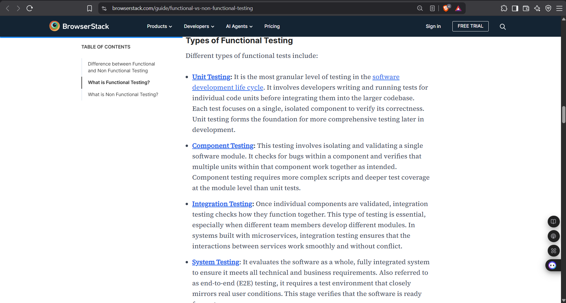
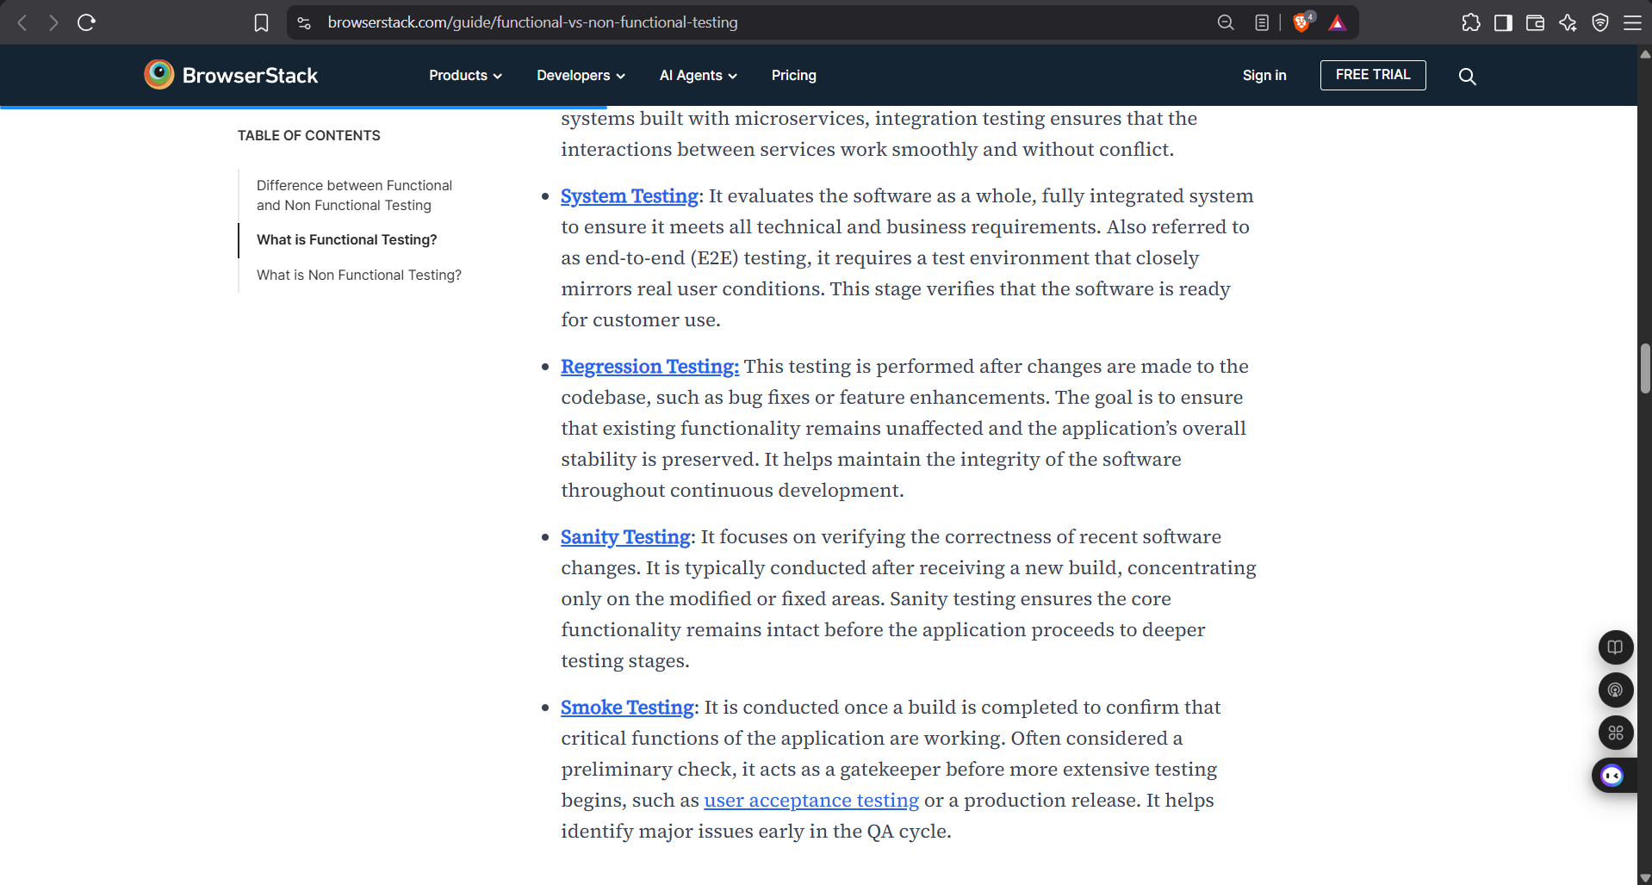
- Unit Testing
Most granular level of testing. Developers write tests for individual code units before integrating them. Each test focuses on a single, isolated component.
- Component Testing
Isolates and validates a single software module. Checks for bugs within a component and verifies that multiple units work together as intended.
- Integration Testing
Checks how individual components function together. Essential when different team members develop different modules, especially in microservices architectures.
- System Testing (E2E)
Evaluates the software as a fully integrated system to ensure it meets all technical and business requirements. Requires an environment that mirrors real user conditions.
- Regression Testing
Performed after code changes (bug fixes or enhancements) to ensure existing functionality remains unaffected and overall stability is preserved.
- Sanity Testing
Focuses on verifying the correctness of recent software changes. Typically conducted after a new build, concentrating only on modified or fixed areas.
- Smoke Testing
Conducted once a build is completed to confirm that critical functions are working. Acts as a preliminary gatekeeper before more extensive testing begins.

- What is Non-Functional Testing?
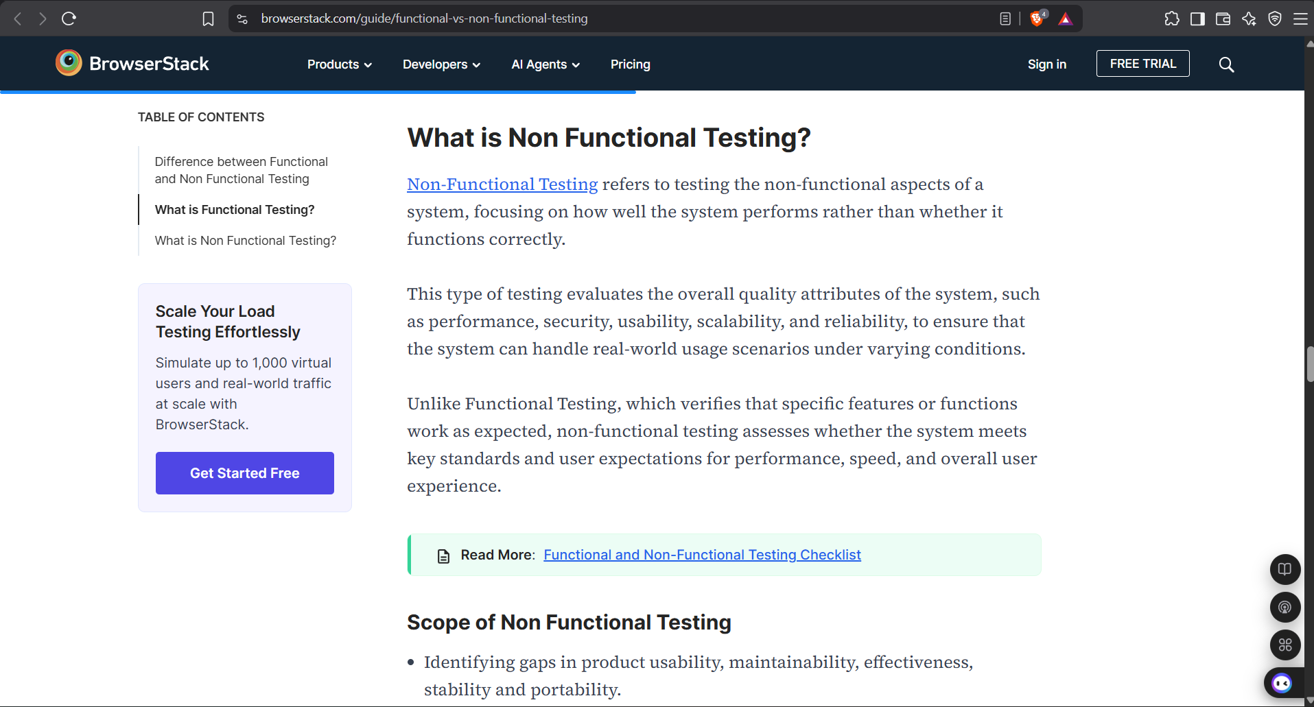
Non-Functional Testing refers to testing the non-functional aspects of a system — focusing on how well the system performs rather than whether it functions correctly.
It evaluates overall quality attributes such as performance, security, usability, scalability, and reliability to ensure the system can handle real-world usage under varying conditions.
Unlike Functional Testing, non-functional testing assesses whether the system meets key standards and user expectations for performance, speed, and overall user experience.
4.1 Types of Non-Functional Testing
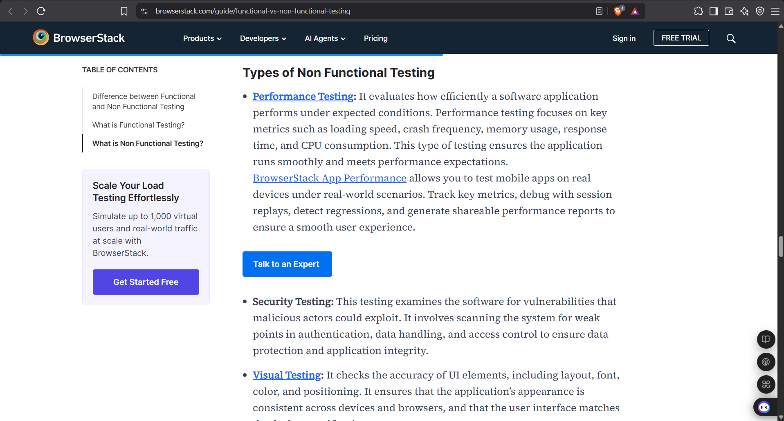
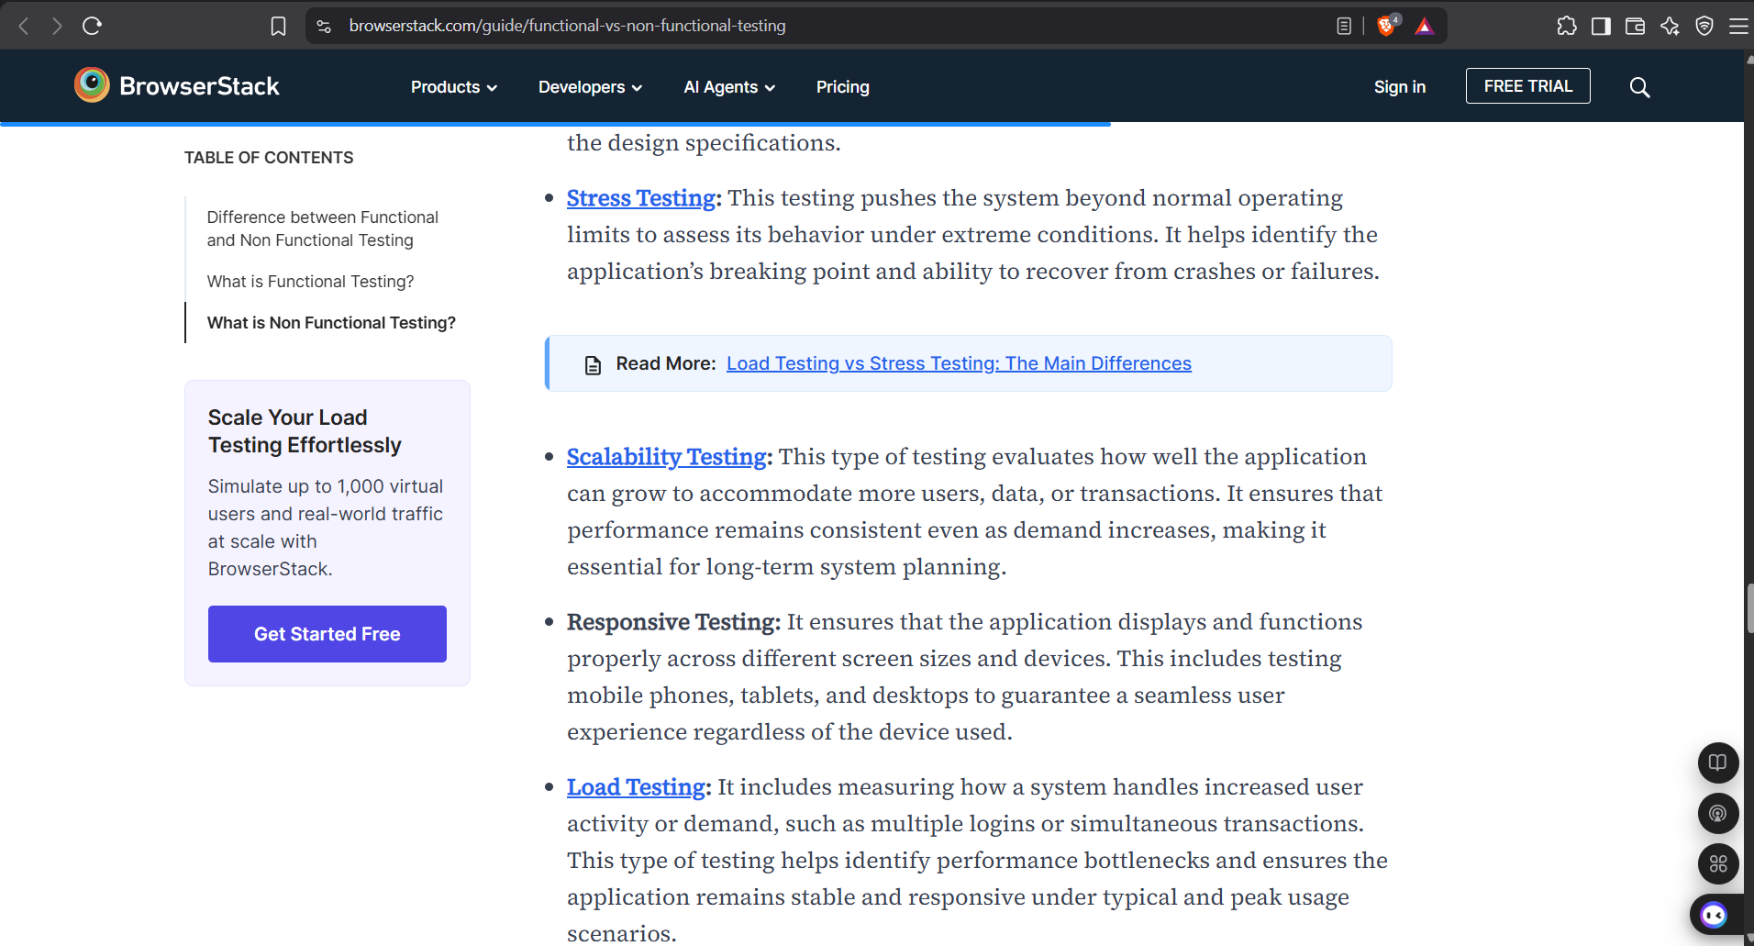
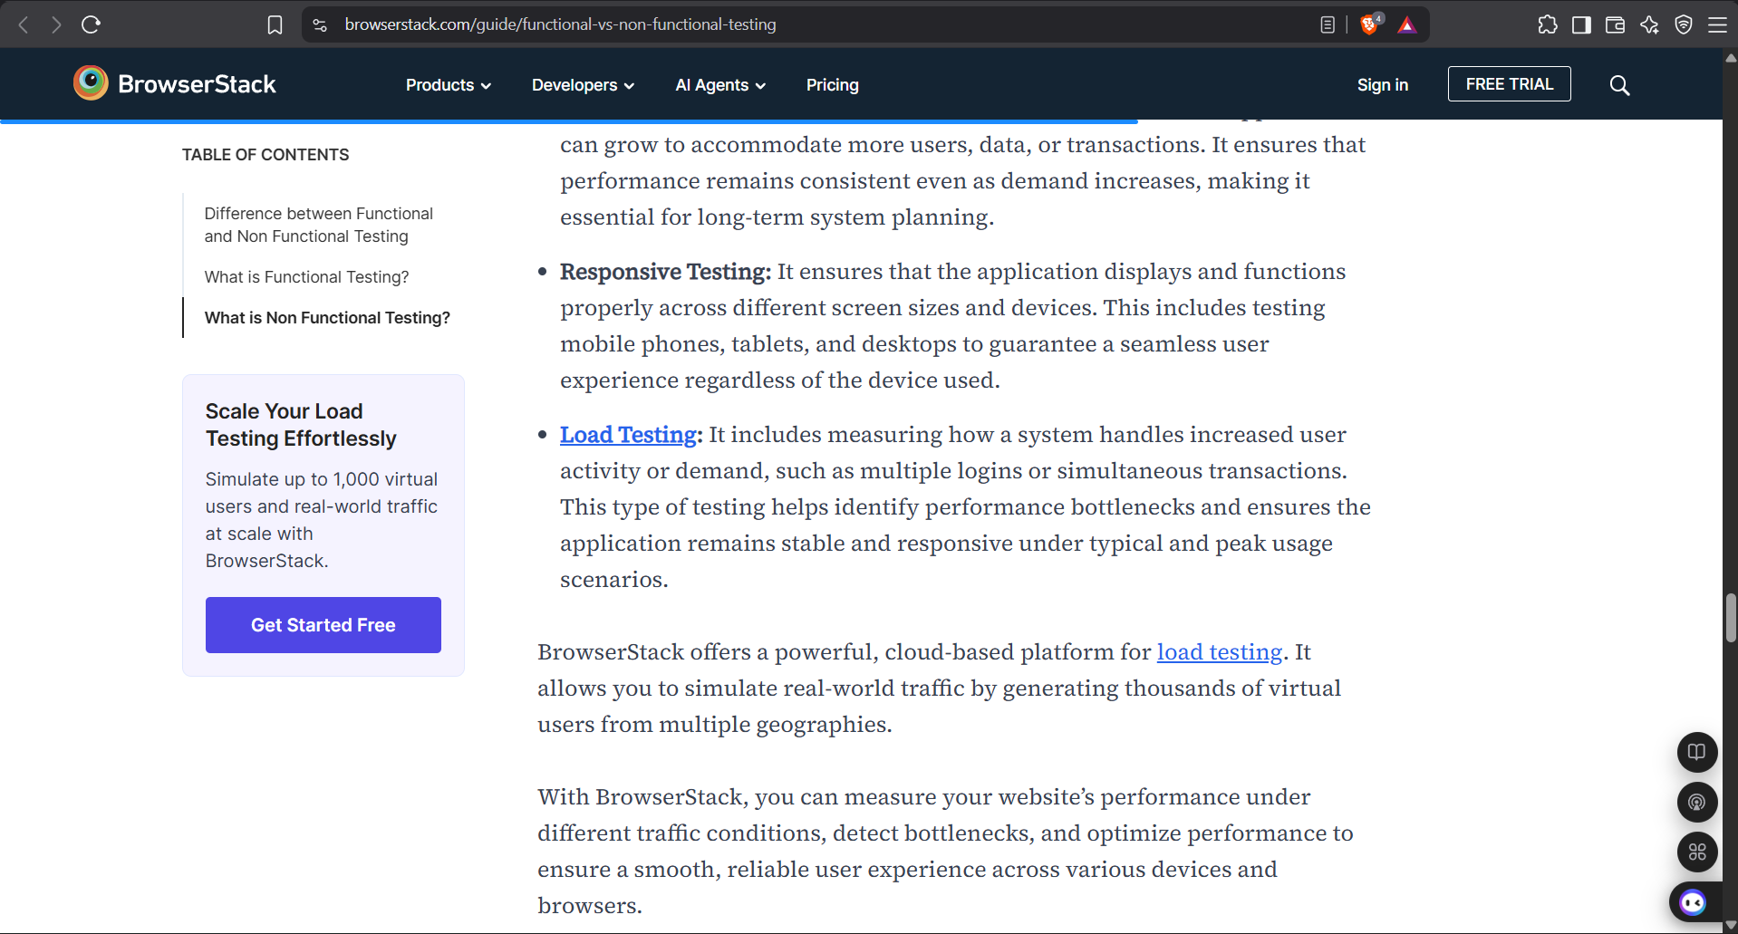
- Performance Testing
Evaluates how efficiently an application performs under expected conditions. Focuses on loading speed, crash frequency, memory usage, response time, and CPU consumption.
- Security Testing
Examines the software for vulnerabilities that malicious actors could exploit. Scans for weak points in authentication, data handling, and access control.
- Visual Testing
Checks the accuracy of UI elements (layout, font, color, positioning). Ensures consistent appearance across devices and browsers.

- Stress Testing
Pushes the system beyond normal operating limits to assess behavior under extreme conditions. Identifies the breaking point and recovery ability.
- Scalability Testing
Evaluates how well the application can grow to accommodate more users, data, or transactions while maintaining consistent performance.
- Responsive Testing
Ensures the application displays and functions properly across different screen sizes and devices (phones, tablets, desktops).
- Load Testing
Measures how a system handles increased user activity or demand. Helps identify performance bottlenecks under typical and peak usage scenarios.
- Example of a Functional Test
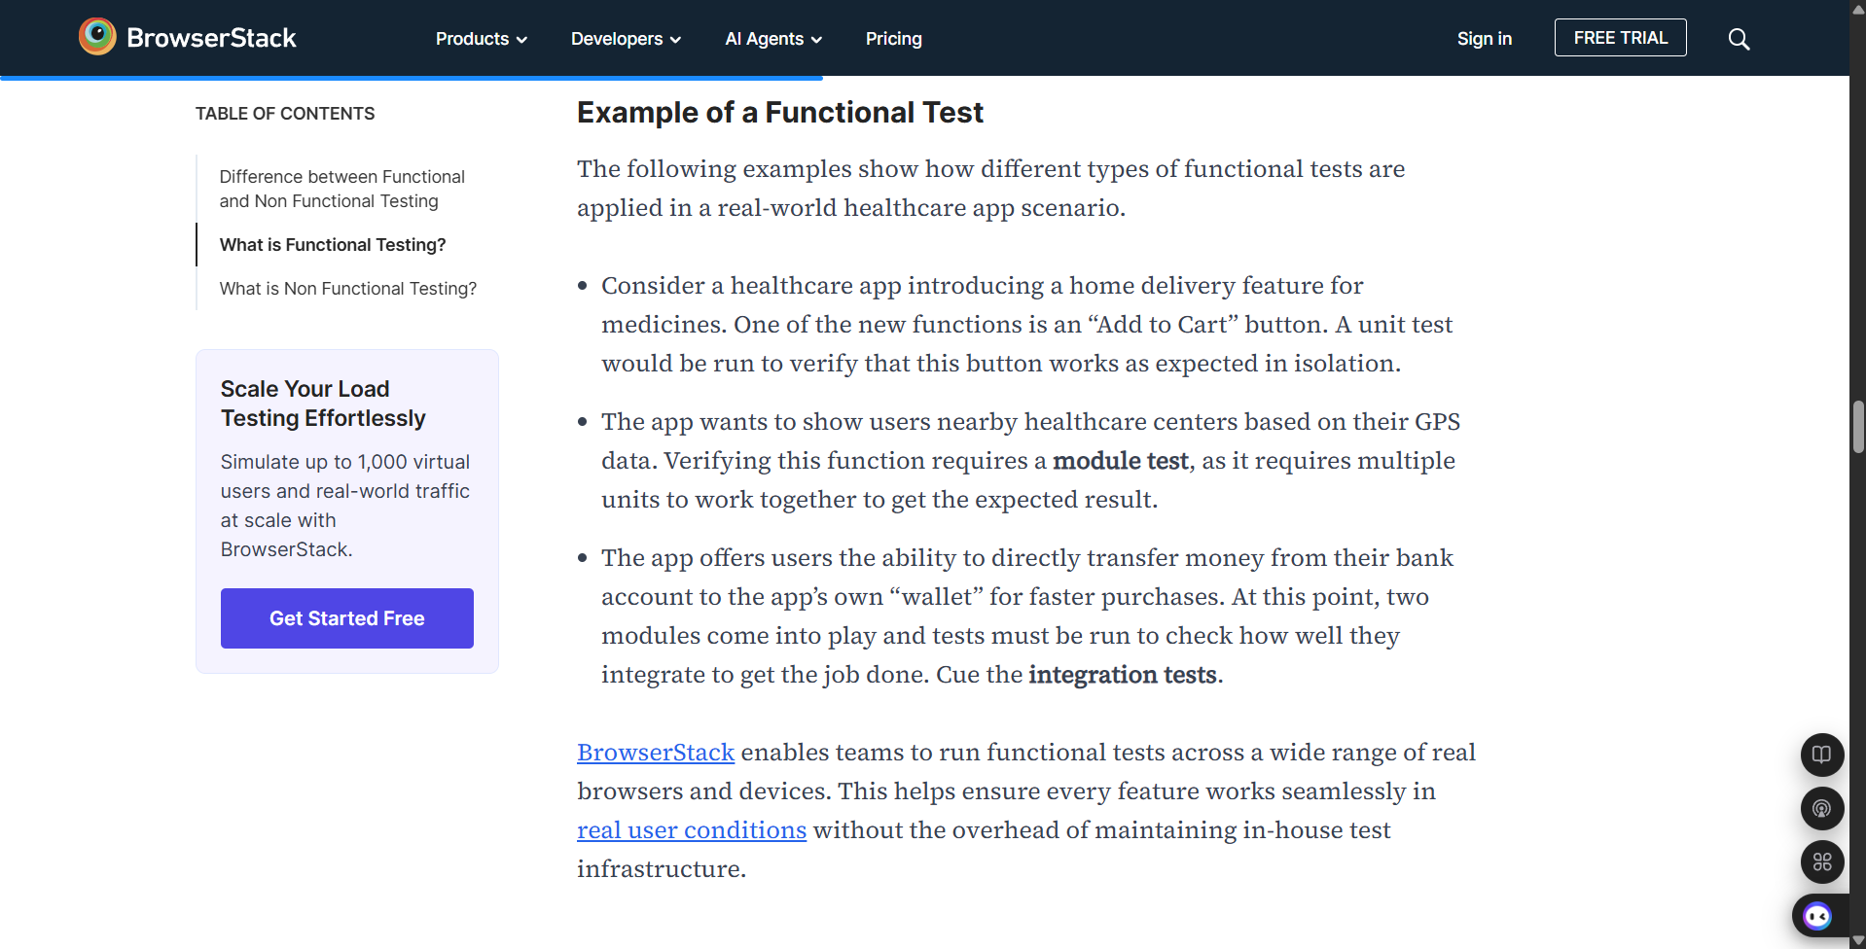
Healthcare app scenario illustrating different functional test levels:
- Unit Test: “Add to Cart” button tested in isolation for the new home-delivery feature.
- Module Test: Showing nearby healthcare centers based on GPS data (multiple units working together).
- Integration Test: Transferring money from a bank account to the app’s wallet (two modules integrating).
- Conclusion
Both functional and non-functional testing are essential components of a comprehensive quality assurance strategy.
Functional testing ensures the software does what it is supposed to do. Non-functional testing ensures it does so efficiently, securely, and reliably under real-world conditions.
Organizations that invest in both deliver higher-quality products, reduce post-release defects, and provide superior user experiences. Platforms like BrowserStack enable teams to run both types of tests on real devices and browsers at scale.
Source: https://www.browserstack.com/guide/functional-vs-non-functional-testing

